Bureaucracy Breaker
Don’t fill forms. Chat with them.
Hackathon: Hackxios 2K25
Track: AWS / Kiro Prize Track
Team Name: Commit_Crew
Team Size: 4

🔗 Project Links (START HERE)
LinkedIn Project Post:
<PASTE LINK HERE – once backend guy posts>
GitHub Repository:
https://github.com/ManishKhandve/Hackaxios2.git
Hashnode Blog (Build & Learnings):
<PASTE HASHNODE LINK HERE>

🧠 One-Line Summary
Bureaucracy Breaker is a browser-based assistive system that helps users complete complex government and scholarship forms by turning them into a guided, conversational experience—without bypassing security or automating submissions.

📌 What This Document Contains
This document explains:
- The real-world problem behind bureaucratic forms
- The assistive solution we built
- System architecture and flow
- Key features and screenshots
- Challenges, tradeoffs, and learnings
- How Kiro supported planning and execution

1. Problem Statement
Government and institutional forms—such as scholarship applications, visa forms, and public benefit requests—are difficult for users to complete correctly.
The difficulty is not data entry, but understanding.
These forms are often written in administrative or legal language that assumes prior knowledge. Instructions are unclear, fragmented, or buried inside long documents. Small mistakes—incorrect formats, misunderstood fields, or missing details—can lead to rejection, delays, or repeated submissions.
As a result:
- Users fear making mistakes
- Applications are frequently incomplete or incorrect
- People rely on agents or middlemen just to fill forms
- Time and money are wasted on avoidable assistance
This problem disproportionately affects:
- Students applying for scholarships or educational benefits
- First-time applicants unfamiliar with government processes
- Elderly users and non-technical users
- Immigrants and individuals navigating unfamiliar systems
Existing solutions focus on automation or form digitization, but they fail to address the core issue:
users do not understand what is being asked or where to find the required information.
Most people do not want a bot to submit forms for them.
They want clear guidance, simple explanations, and confidence that they are filling the form correctly.
This project addresses bureaucracy as a comprehension and usability problem, not an automation problem.

2. Solution Overview
Bureaucracy Breaker is a browser-based assistive system that helps users complete complex government and scholarship forms by turning them into a guided conversational experience.
Instead of forcing users to interpret confusing instructions or legal terminology, the system behaves like a calm digital clerk that explains each form field in plain language and guides the user step by step.
The solution works as follows:
- The user logs in to the official website manually
- A browser extension activates on the form page
- Each form field is explained before input is requested
- The user answers one question at a time
- The system fills the corresponding field side-by-side
- The user reviews and submits the form manually
At no point does the system bypass security mechanisms, automate logins, or submit forms on behalf of the user.

Key Design Principles
The solution is built on the following principles:
- Assistive, not automated
The system supports the user without taking control.
- Explanation before action
Every field is explained before input is requested.
- Human-in-the-loop
The user remains responsible for review and submission.
- Security and compliance first
CAPTCHA handling, authentication, and submission are always manual.

What Makes the Solution Different
Most existing tools focus on:
- Digitizing forms
- Bypassing manual steps
Bureaucracy Breaker focuses on:
- Understanding form intent
- Reducing confusion and fear
- Respecting real-world government systems

3. Technologies Used
Bureaucracy Breaker was built using a modern web stack chosen for reliability, security, and rapid iteration within a hackathon environment.
Each technology was selected to support an assistive, human-in-the-loop design rather than unsafe automation.

Frontend (User Interface)
- React
Used to build the sidebar chat interface that guides users through form completion.
React enables a responsive, interactive UI that updates dynamically as the conversation progresses.

Backend (Logic and Coordination)
- Python (FastAPI)
Acts as the central reasoning layer of the system.
The backend manages session state, determines the next form field to handle, validates user responses, and coordinates AI interactions.

AI Layer
- Large Language Model API
Used strictly for explanation and reasoning.
The AI converts complex form fields into plain-language questions and guides users without making assumptions or guarantees.

Browser Extension
- Chrome Extension (Manifest V3)
Injects a sidebar into live form pages.
Detects and fills form fields based only on user-provided answers.
The extension operates entirely within browser security constraints and does not bypass authentication or CAPTCHA mechanisms.

Supporting Tools
- GitHub – Version control and team collaboration
- Google Docs – Structured project documentation
- Hashnode – Public blog and build reflection

4. System Architecture & Flow
Bureaucracy Breaker is built using a three-layer assistive architecture that keeps users in control while safely integrating AI guidance.
The system is divided into independent layers, each with a clear responsibility.

High-Level Architecture
The system consists of:
- Browser Extension
Runs on live form pages, injects a sidebar, highlights fields, and fills inputs using user-provided answers only.
- Web Application (Frontend)
Displays the chat interface, shows explanations, collects responses, and communicates with the backend.
- Backend API (Logic + AI)
Maintains session state, decides the next field to handle, generates explanations, and validates user input.
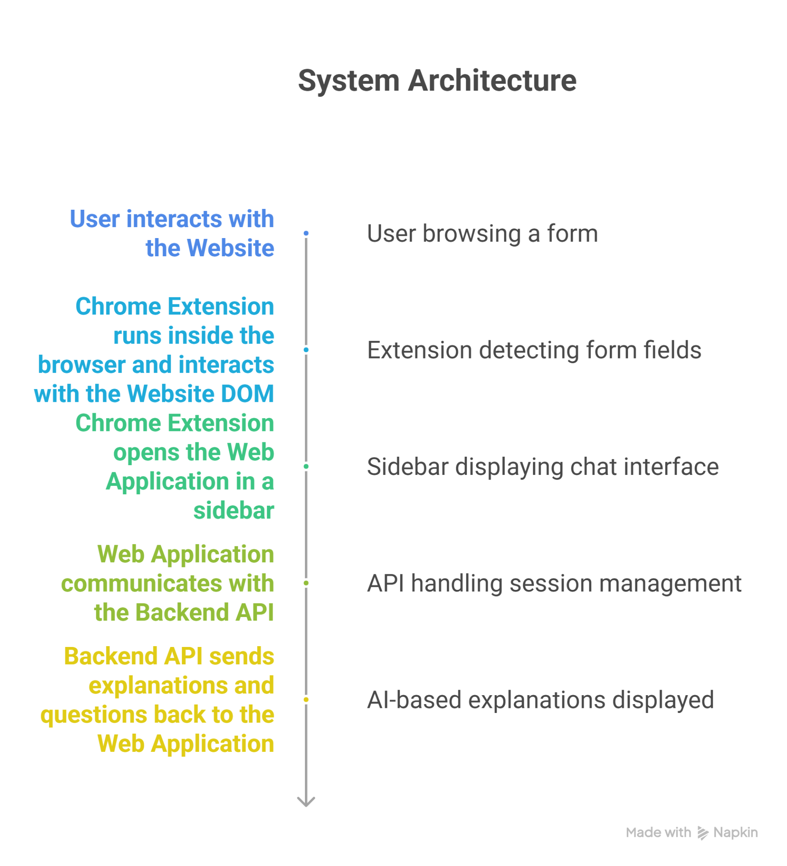
High-level architecture showing interaction between extension, frontend, and backend.

Interaction Flow
- User logs in and opens a form manually
- Extension is activated and opens the chat sidebar
- Backend explains the current field
- User answers via chat
- Extension fills the corresponding input
- User reviews and submits manually
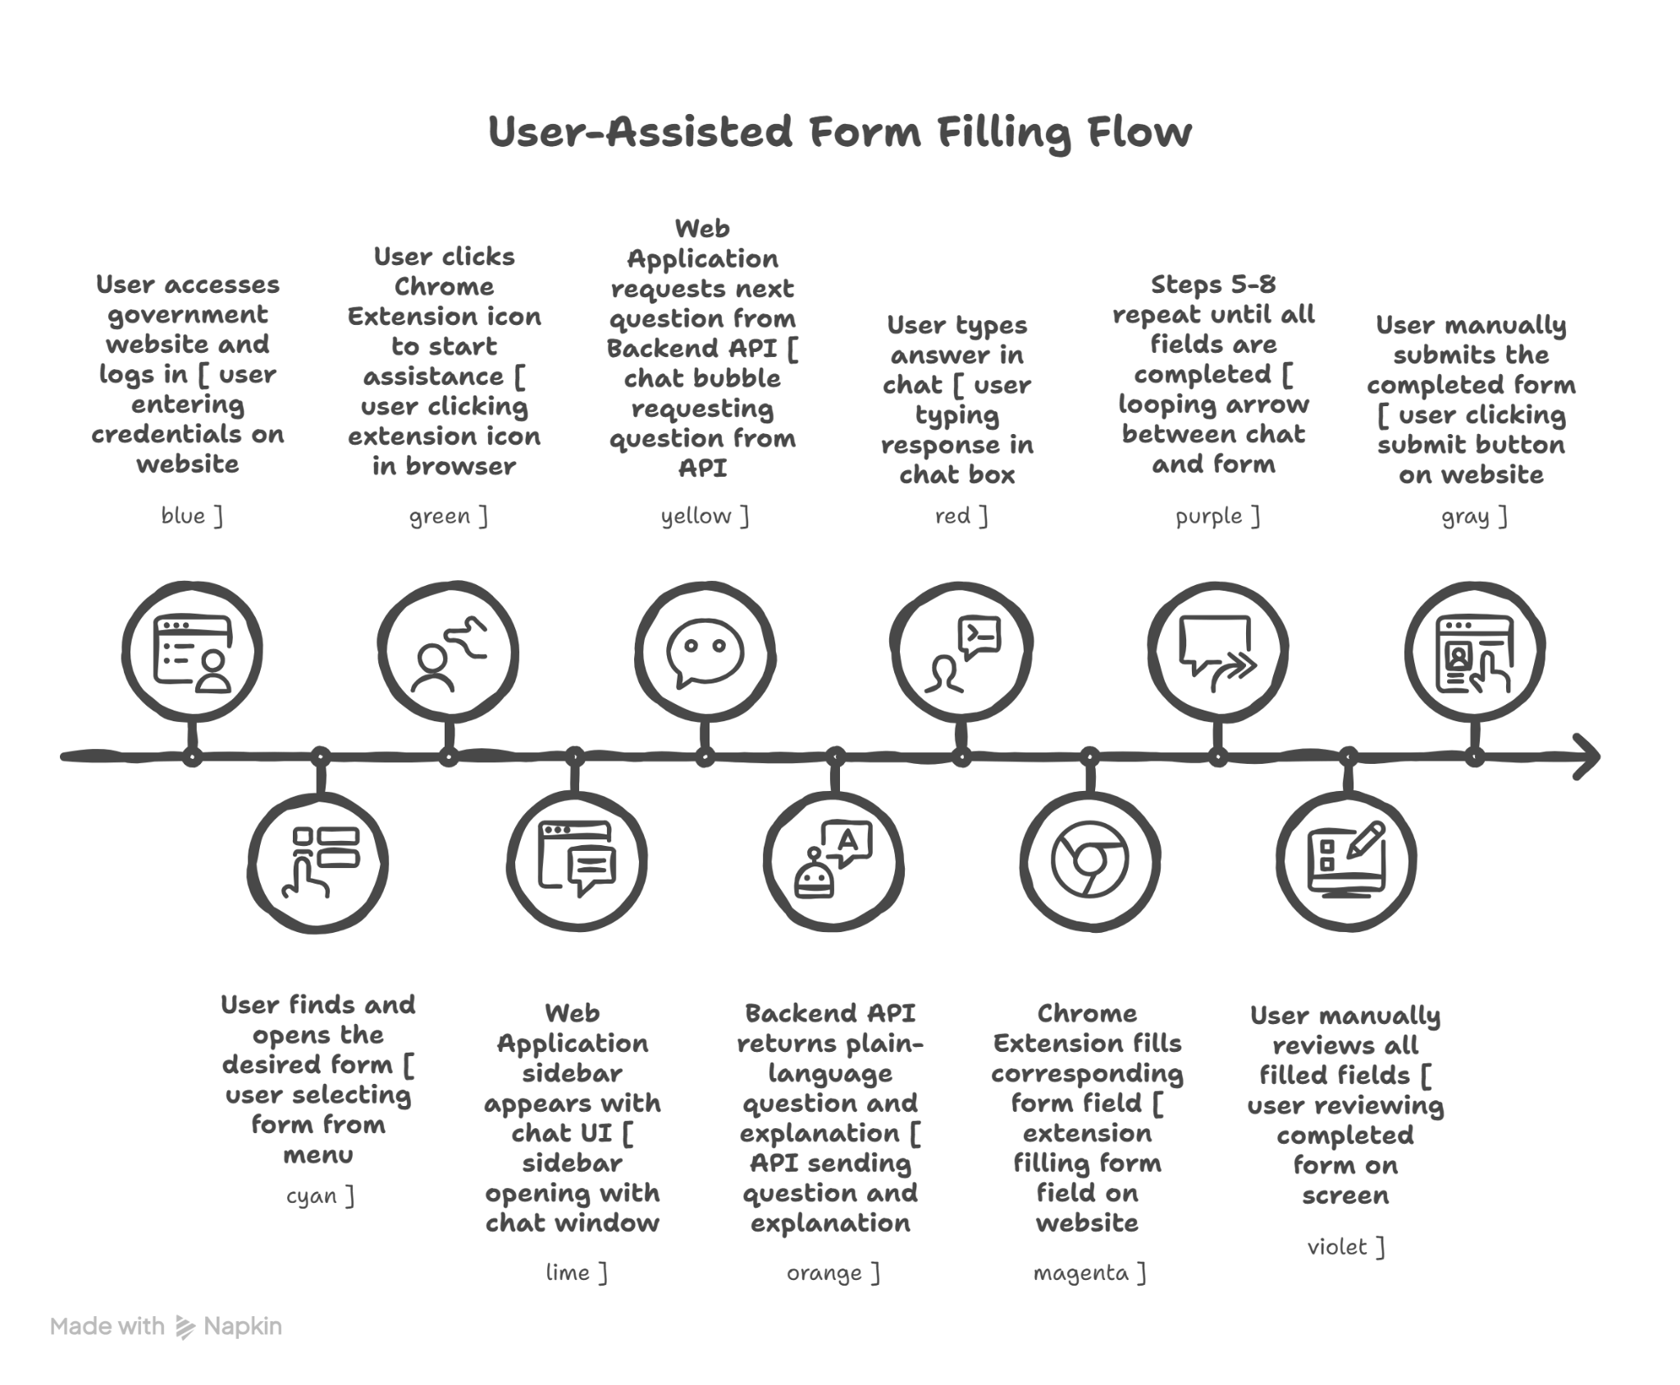
User-controlled form assistance flow.

Security Constraints
- No automatic login or submission
- No CAPTCHA handling
- No credential storage
- AI never accesses the browser DOM
This design ensures compliance with real-world government portals.

6. Screenshots / Demo Walkthrough
This section visually demonstrates how Bureaucracy Breaker assists users while they fill complex forms, without taking control away from them.

Chat-Based Form Guidance
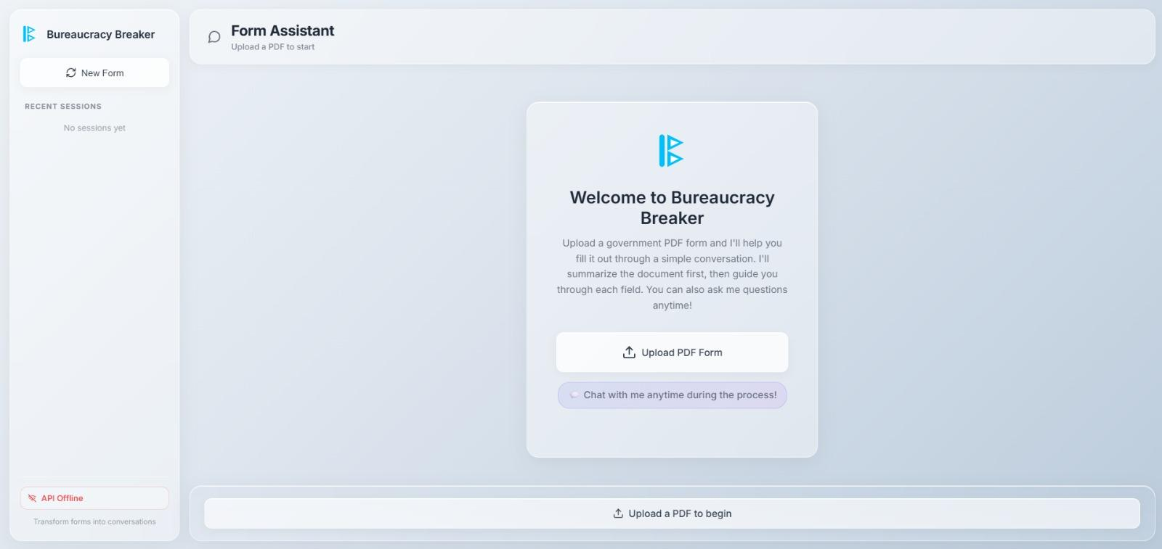
The sidebar chat explains a form field in plain language before asking for input.

Side-by-Side Form Autofill
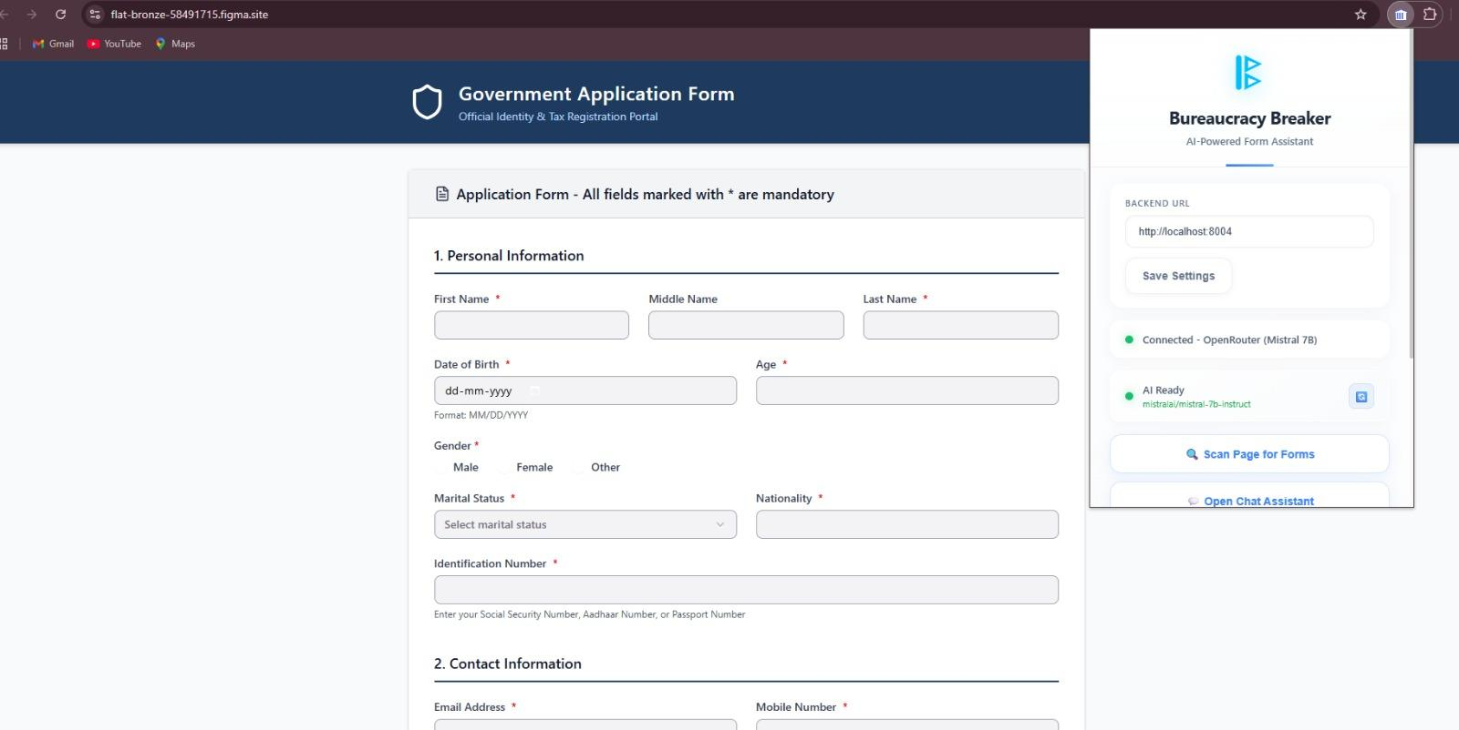
User-provided answers are filled directly into the form while remaining visible for review.

7. Challenges, Learnings & Future Scope

Challenges Faced
Building Bureaucracy Breaker revealed challenges that were less technical and more rooted in real-world complexity.
Government and institutional forms are inconsistent in structure, use unclear terminology, and often behave differently than expected. Simple elements such as checkboxes, radio groups, and conditional fields required careful handling to avoid incorrect assumptions.
Another major challenge was resisting unsafe automation. Features like OCR, auto-login, and automatic submission were intentionally excluded because they introduce reliability, security, and ethical risks—especially on government portals.
Designing AI behavior was also non-trivial. The system had to explain fields clearly without making legal guarantees, assumptions, or decisions on behalf of the user.

Key Learnings
- Bureaucracy is fundamentally a comprehension problem, not a data-entry problem
- Assistive systems are more reliable than fully automated ones in sensitive domains
- Explaining why a field exists is often more valuable than filling it quickly
- Engineering discipline matters more than feature count under hackathon pressure
Kiro played an important role in slowing down decision-making, helping reason through tradeoffs, and keeping the system structured and explainable throughout development.

Future Scope
Future extensions of the system could include:
- Voice-based assistance (speech-to-text and text-to-speech)
- Support for scanned PDFs using OCR
- Multilingual explanations for broader accessibility
- Persistent user sessions for long or multi-day forms
These features were intentionally scoped out of the hackathon prototype to preserve reliability and clarity.

Conclusion
Bureaucracy Breaker demonstrates that complex forms do not need aggressive automation to become usable.
By focusing on explanation, user control, and ethical design, the system transforms bureaucracy into a calmer, more understandable experience—one conversation at a time.

